# ROCO507Z Advance Robot Design and Prototyping: Project Proposal for an Autonomous Health Care Logistics Robot using NeoSLAM.

James Ravenhill- 10699148 Ben Evans - 10362555

# Abstract

We propose an easily disinfected mobile robot, suitable for delivering items to hospital inpatients. This is intended to reduce human exposure to infectious agents such as COVID-19. Final delivery is achieved by sliding loaded trays onto beside tables, where the intended tray is matched to the surface height using a scissor lift mechanism. For the robot’s locomotion, an omnidirectional tripod platform is proposed, suitable for safe navigation in crowded spaces.

# Introduction

### Purpose

A logistics robot capable of multiple functions is extremely beneficial, although its size must be taken into consideration. In narrow corridors of busy hospitals, it would be unfavorable to have a large bulky autonomous robot. The main purpose of our robot is to transport materials around a hospital where needed. Materials such as paperwork, medical equipment (blood pressure cuffs, Dressings etc...) or even laboratory samples can be transported around a hospital without the supervision of a nurse/doctor.

Another function of our design will to be to incorporate an air filtration system, this is not the main aim of the design but would be beneficial to incorporate. A simple air tunnel containing UVC lights will clean the air around the hospital during the delivery of items.

### Navigation

The problem of autonomous navigation can be solved using a combination of methods. Path planning should be optimized for determining a collision-free or low traffic path. In the busy environment of a hospital, it is essential to follow a path which copes for a highly dynamic environment. In order to do this, simultaneous localization and mapping (SLAM) along with a neuro-evolution multi-layer perception (MPL) based controller (Matt Knudson, 2011) can be combined, creating a NeoSLAM**,** (Zhen An, 2016) method of navigation. The addition of LIDAR sensors, cameras and motor encoders can also be used to improve the accuracy of the localization and mapping process, but all may not be necessary. The use of motion sensors for example, can be place in corridors of hospitals. These will provide data as to how much traffic is in that area, this will contribute to the decision of determining the best possible path for the robot to take.

# Aims and objectives.

CAD Design of several modular mechanical units:

* A cabinet housing multiple trays, any one of which may be ejected
* A wheeled base, suitable for locomotion in constrained hospital environments
* A scissor lift mechanism, suitable for matching the active tray to its destination surface

Development of control software, for use in CoppelliaSim:

* Direct human control
* Simple ultrasound object avoidance reflexes
* Integration with ROS
* Implementation of NeoSLAM for autonomous navigation

#### Proposed Design

## Locomotion

Independent steering of driven wheels can afford a mobile robot, such as the Thorvald, excellent maneuverability.

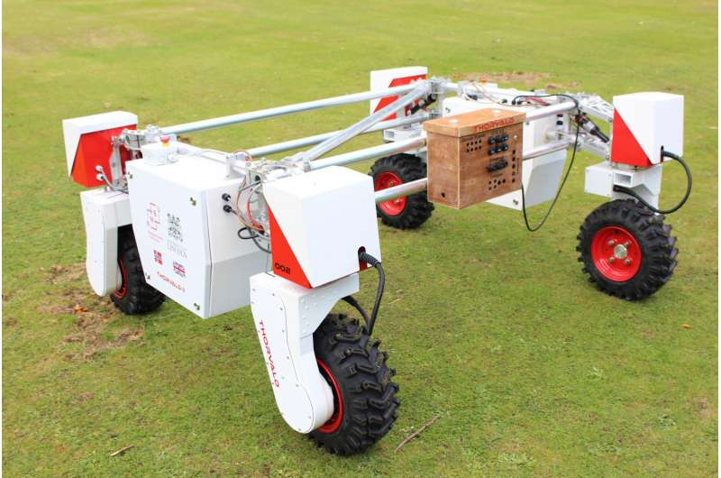

Figure 1: omnidirectional robot, (New mobile robot to support agri-tech experiments in the field, n.d.)

However, some aspects are undesirable for our intended application:

* The steering rotation axis intersects the driving rotation axis, requiring steering to be implemented high above the wheel. Not only does this raise the center of gravity, but the steering joint is subject to increased leverage.
* A more compact and simpler robot could be achieved using a tripod configuration of drive units.

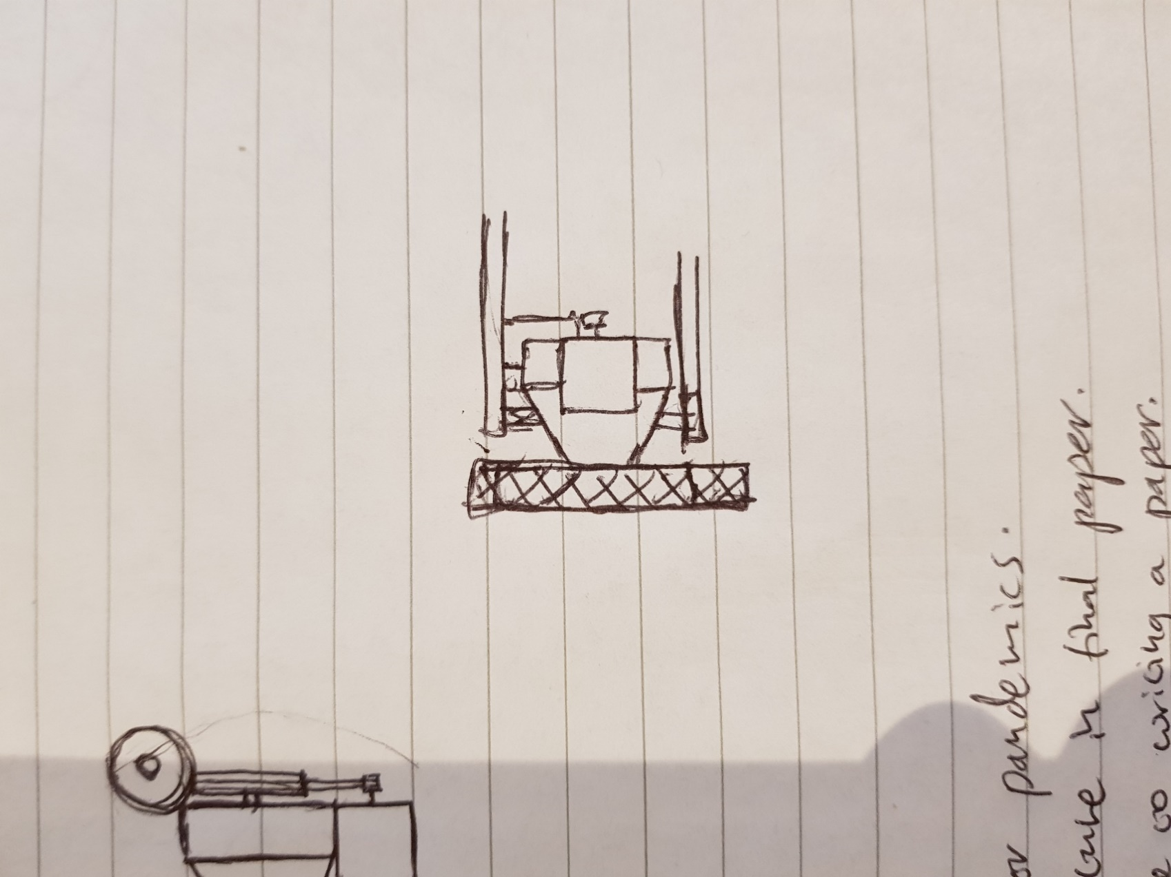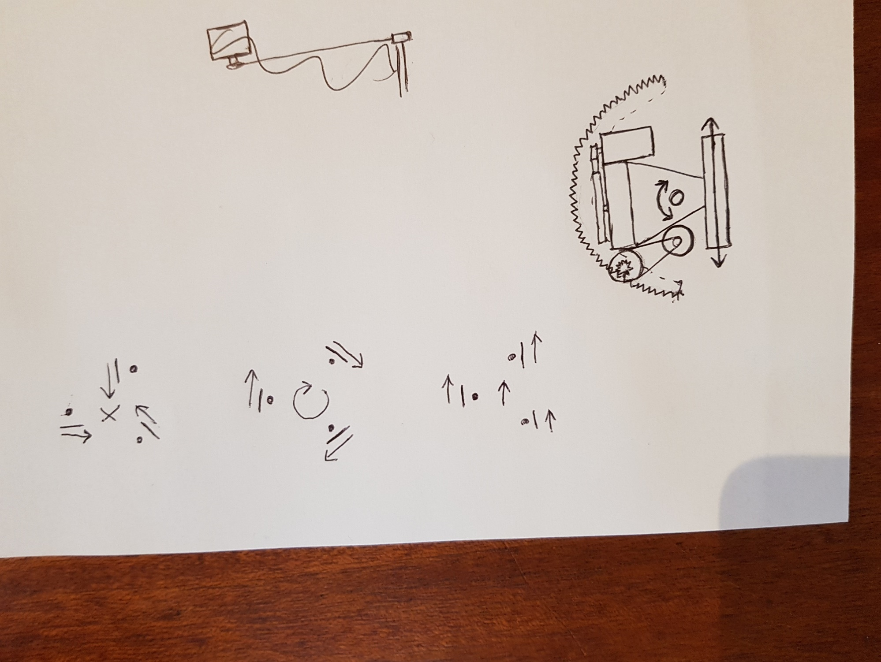

Figure 2a, 2b: sketches of single omnidirectional drive unit

As shown in these top and side views, the steering axis is offset, enabling the entire unit to be accommodated within the height of the wheel. Additionality, the steering pivot can be supported both above and below the central “knuckle”. Steering is achieved by a driven gears engagement with a half-moon rack attached to the robot frame. To provide lightweight, compact, and powerful actuation BLDCs are used as both the driving and steering motors. Appropriate gear reductions will be required.

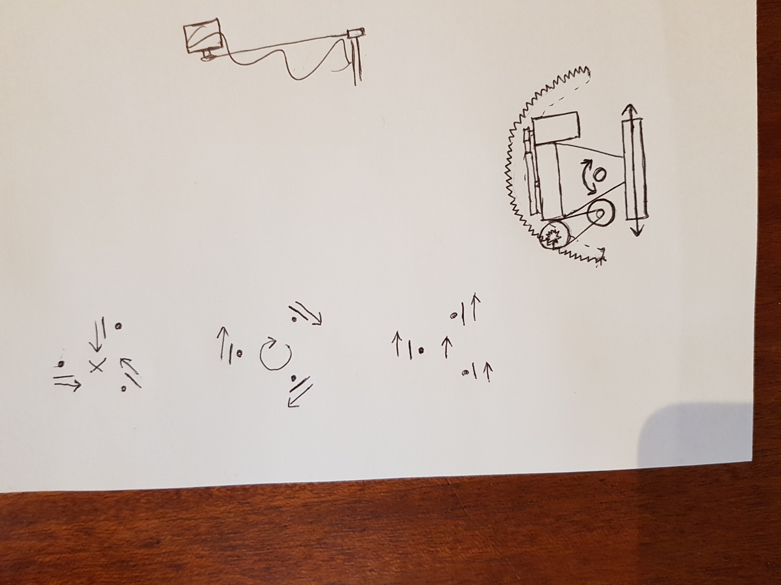

Figure 3: Omnidirectional movement using three drive units

These kinematics allow vectoring in any given direction, rotation on the spot, or a combination of the two. Additionally, the wheels may all be pointed inwards to lock the robot in place when not driven.

Delivery mechanism

One method of delivering items to patients is by ejecting loaded trays from a cabinet.

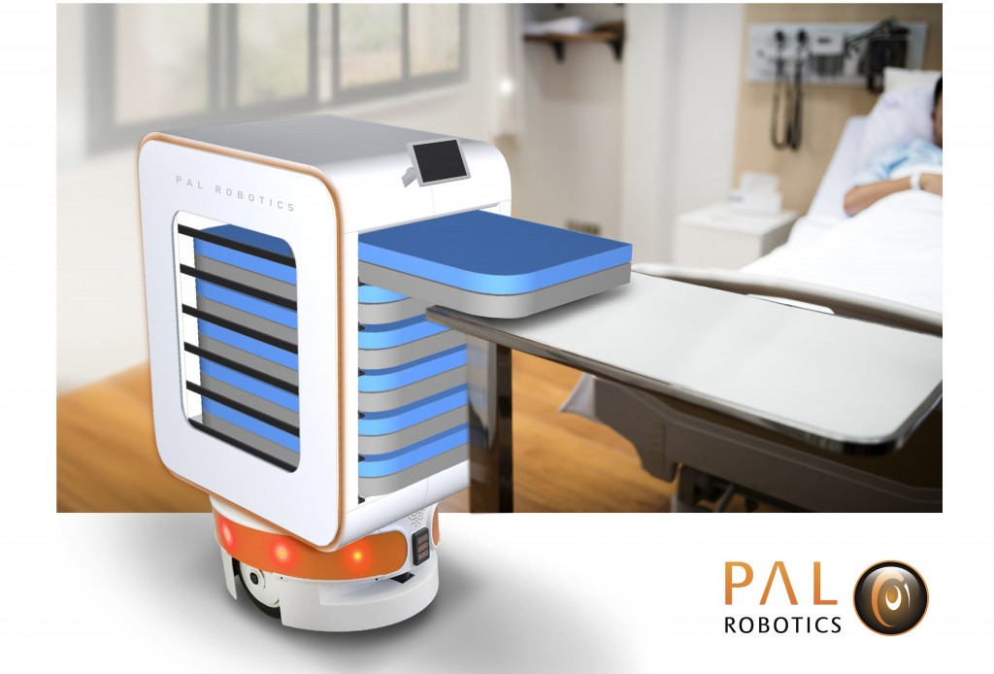

Figure 4: tray ejection application, (COVID-19 and our robots: ready to help fight coronavirus in hospitals, n.d.)

## Basic Ejector mechanism

Once the scissor lift positions the correct tray (through the use of ultrasound sensors to detect its relative vertical position to the table), the ‘ejector unit’ uses a simple arm to slide the tray, as shown from above. A bearing is used at the end of the arm to avoid friction jamming. Each tray access slot is fitted with a sprung flap to prevent contamination of tray contents.

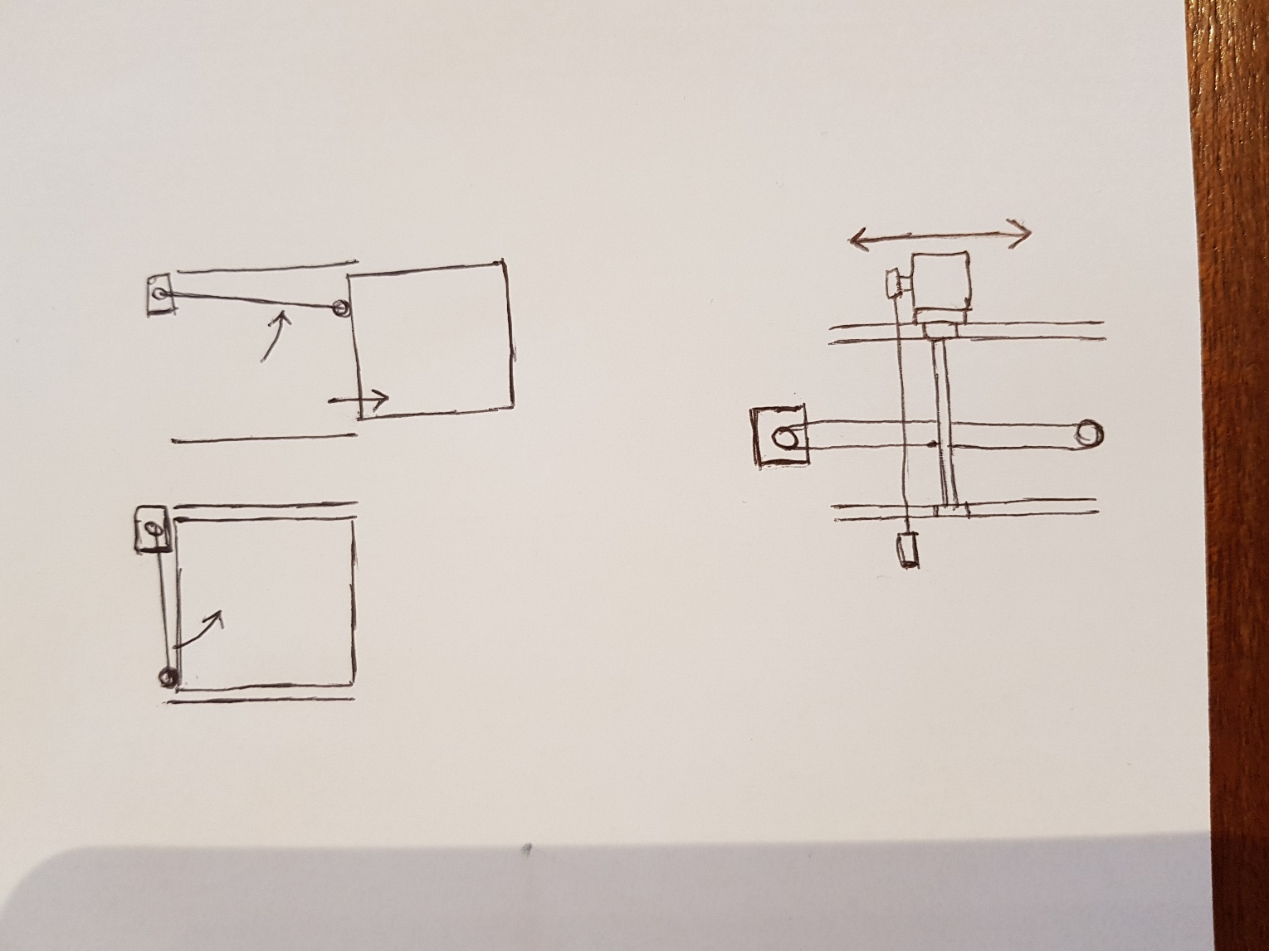

Figure 5: Tray ejection unit

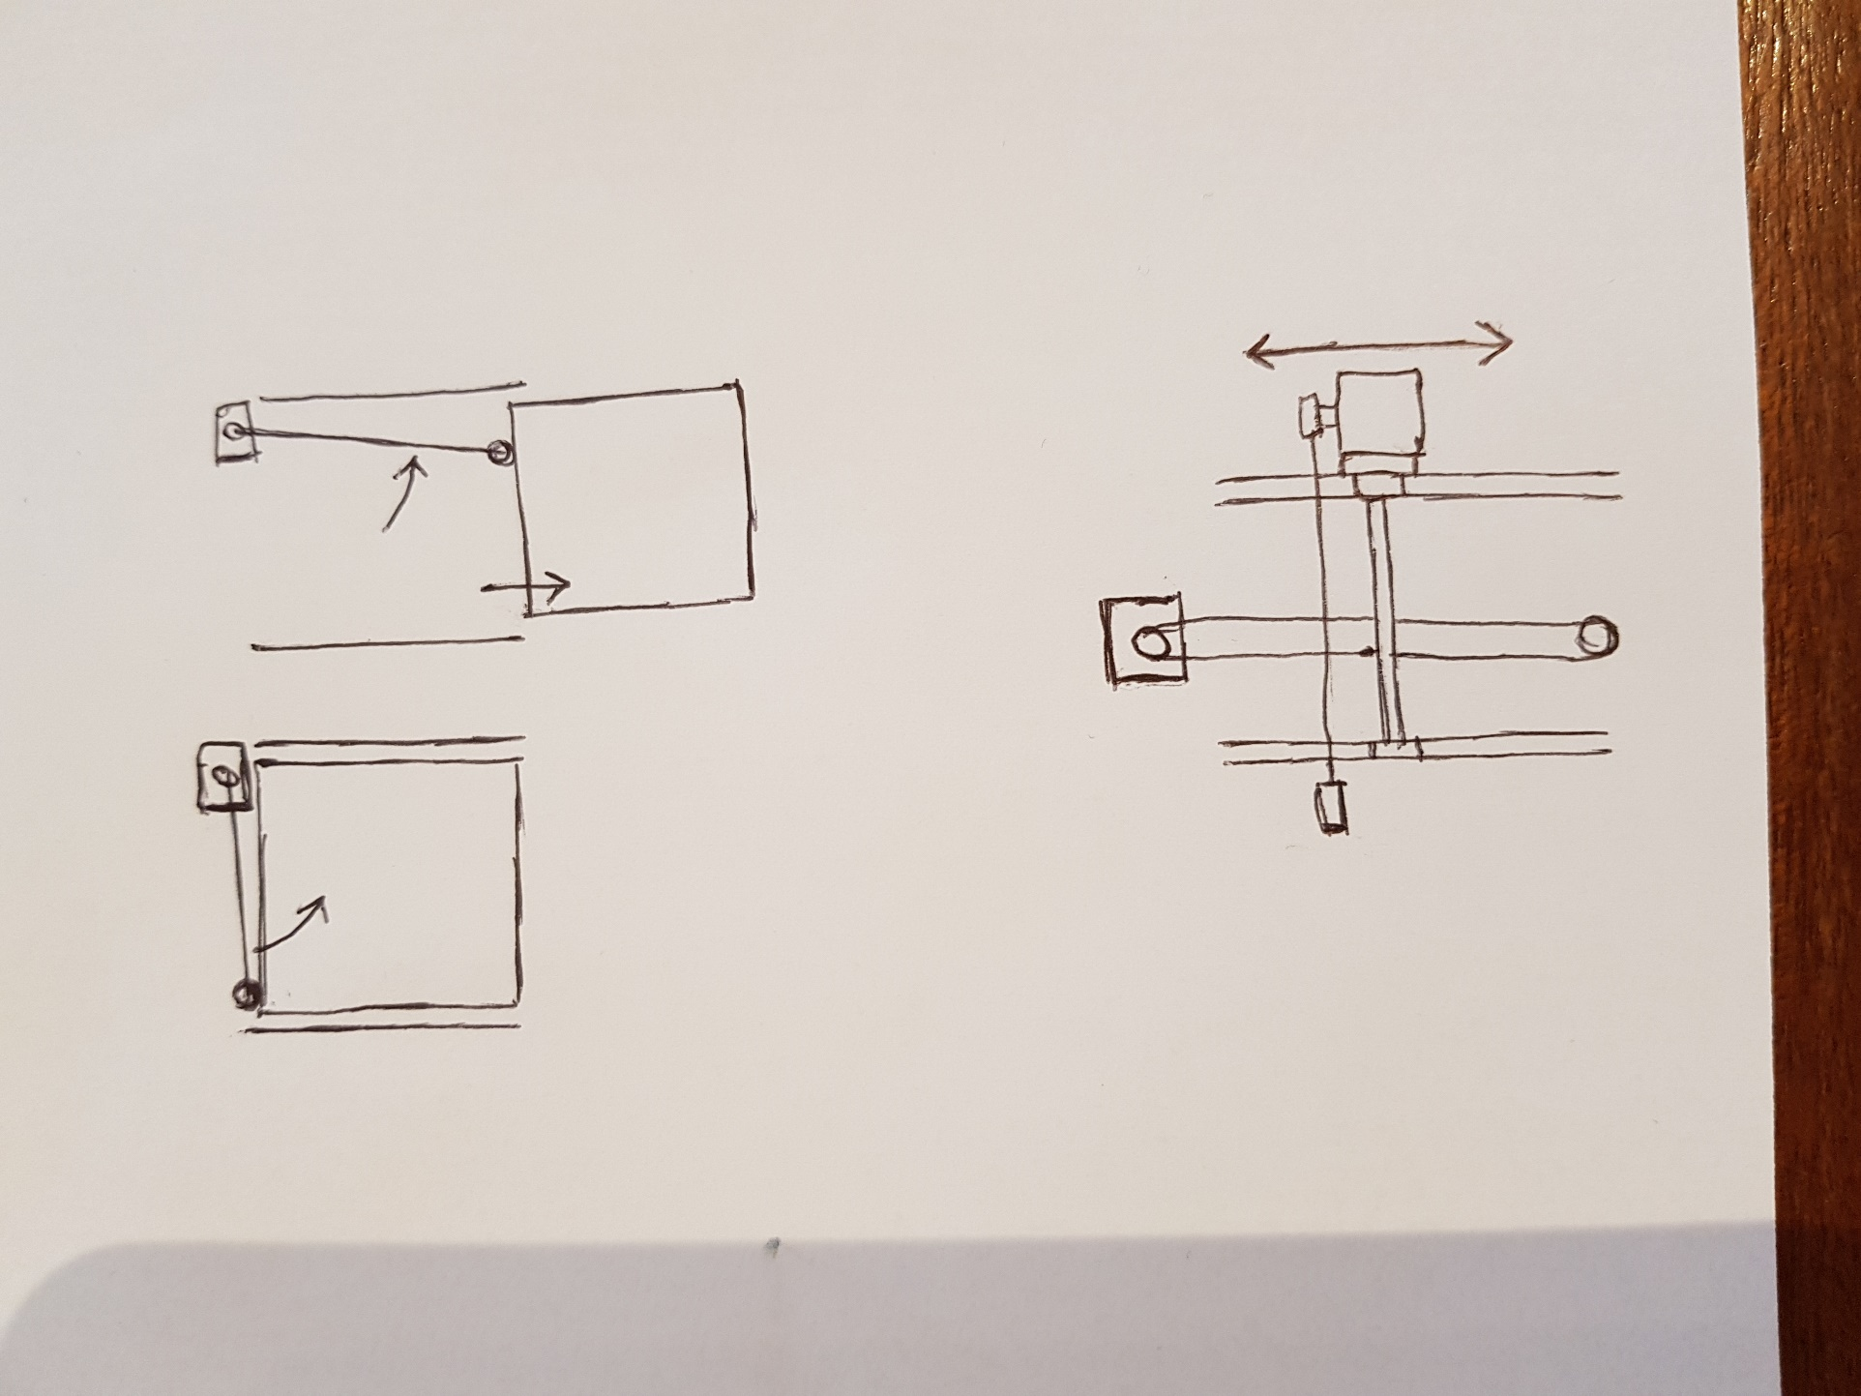As shown from the side (Fig 6), the ejector unit may be positioned behind any single tray by the use of a belt drive. This allows many trays to be handled, but requires only two motors.

Figure 6: Method of positioning the tray ejection unit behind a selected tray

This basic mechanism as described Fig 5,6 is unable to reclaim trays, to achieve this an alternative, more complete method is proposed.

## Collection mechanism

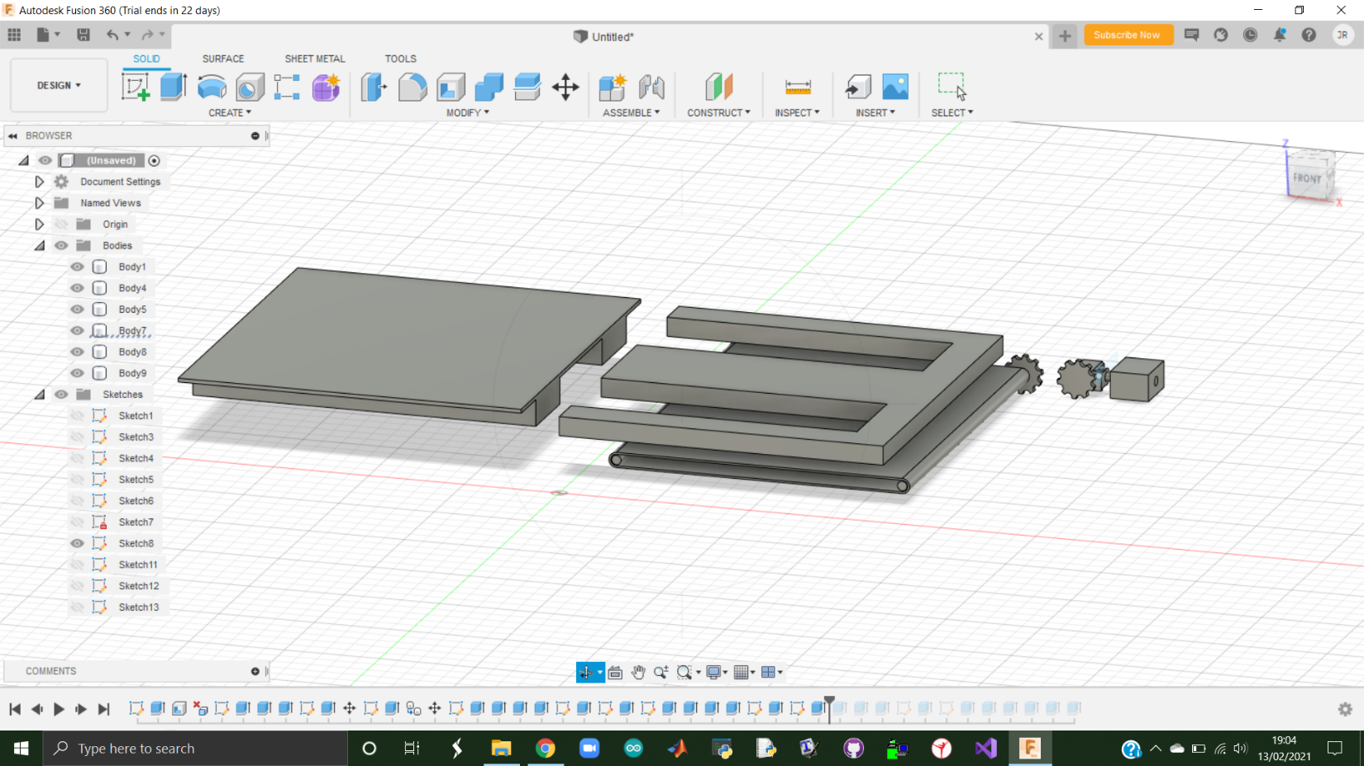

Figure 7: CAD design of tray mechanism setup

The collection mechanism will resemble to that similar of a fork-lift. The dimensions of the tray which is ejected sits within the prongs of the ejection unit. When delivering, the scissor lift mechanism is raised to the correct height, the ejector unit will eject the correct tray. Once the tray if fully ejected the scissor lift mechanism will lower the robot in order to allow contact with the tray and the table. Then the ejector unit will then recall the “forklift” prongs, leaving the usable tray. To collect the tray the robot will perform this sequence in reverse.

## Ejector unit mechanism.

The ejector mechanism will involve a vertically rail, allowing the unit to slide up and down to the correct tray height. Once at the correct tray height it will extend a cog which will marry up with a secondary cog connected to the belt drive of the tray.

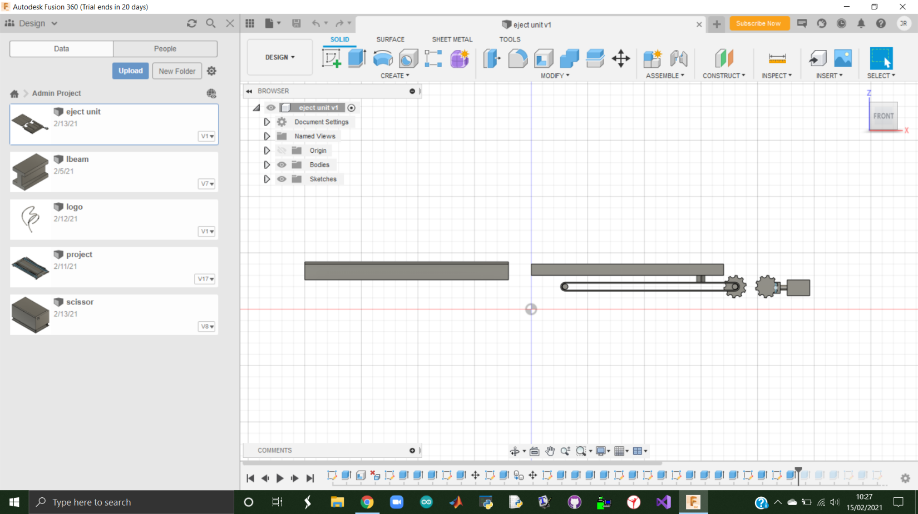

Figure 8: CAD design of tray mechanism (cross-section)

# Appendix

# Bibliography

*COVID-19 and our robots: ready to help fight coronavirus in hospitals*. (n.d.). Retrieved from PAL Robotics: https://blog.pal-robotics.com/covid-19-and-our-robots-ready-to-help-fight-coronavirus-in-hospitals/

Matt Knudson, K. T. (2011). Adaptive navigation for autonomous robots.

*New mobile robot to support agri-tech experiments in the field*. (n.d.). Retrieved from phys.org: https://phys.org/news/2016-10-mobile-robot-agri-tech-field.html

Zhen An, L. H. (2016). Development of Mobile Robot SLAM Based on.